Project title :

Comprehensive Guide to Apple iPhone 13 pro

Team Member :

1.THATHIREDDY JYOTHI REDDY

G-Mail :

1.jyothireddythathireddy@gmail.com

Abstract :

This definitive guide provides an in-depth exploration of the Apple iPhone 13 Pro, covering its cutting-edge features, technical specifications, and practical applications. Key topics include:

* Design and Display: 6.1-inch Super Retina XDR, Ceramic Shield, and durable construction
* Performance: A15 Bionic chip, 6GB RAM, and optimized battery life
* Cameras: Quad-camera setup, Night mode, and advanced video recording capabilities
* Software: iOS 15 features, security enhancements, and intuitive interface
* Connectivity: 5G, Wi-Fi 6, Bluetooth 5.0, and wireless charging
* Accessories and Compatibility: AirPods, Apple Watch integration, and third-party peripherals

This comprehensive guide equips readers with essential knowledge to unlock the full potential of their iPhone 13 Pro, from novice users to tech enthusiasts.

Keywords:

Apple iPhone 13 Pro, Smartphone, Mobile Technology, iOS 15, Camera, Performance, Battery Life.

Process :

# Activity-1

1. Open service now developer Instance
2. Click on All >> search for users
3. Select Users under system security
4. Click on new
5. Fill the following details to create a new user



6.



Click on Submit.

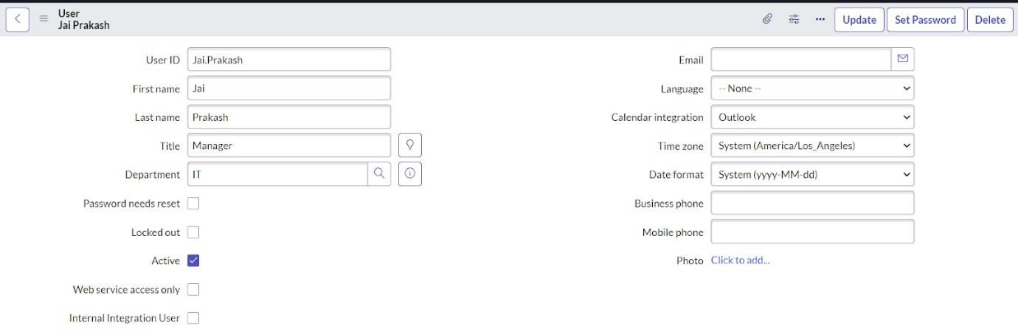

# Activity - 2: Create Groups

1. Open service now.
2. Click on All >> search for groups
3. Select groups under system security
4. Click on new
5. Fill the following details to create a new group.

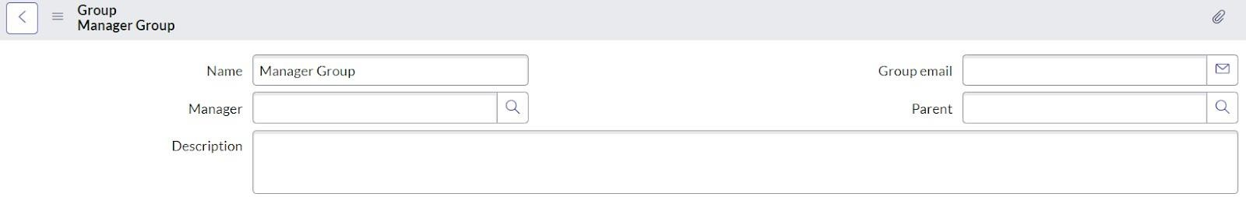

1. Under Group Members, click on edit.
2. Add the user(Jai Prakash) to the Manager Group and click on Save.



8.



It would like below.

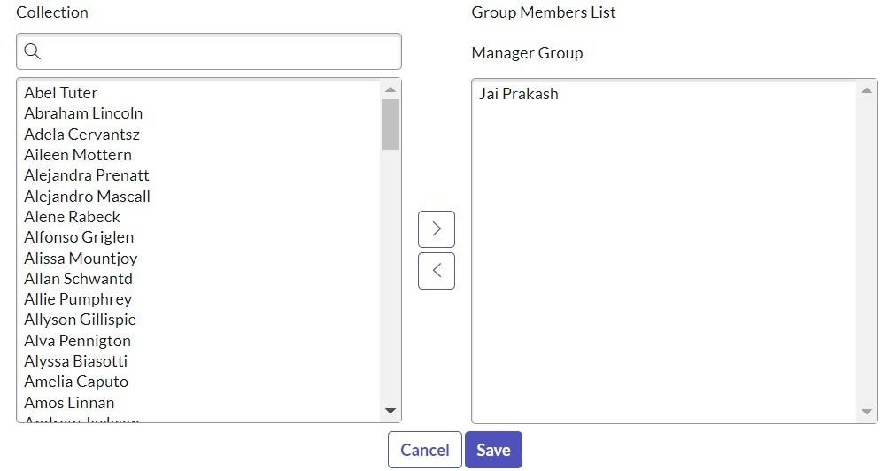

9. Click on save.

# Activity - 3: Create Roles

1. Open service now.
2. Click on All >> search for roles
3. Select roles under system security
4. Click on new
5. Fill the following details to create a new role

6.

Click on submit.

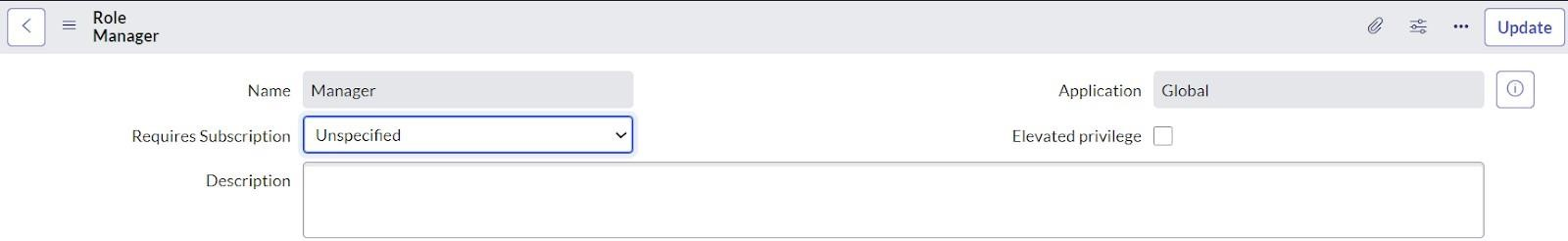

Activity - 4: Creation of Knowledge Base.

1. Go to All >> Search for Knowledge Bases.



1. Click on New.
2. Enter the details for knowledge base as:

Title : Mobiles

Owner : Jai Prakash ( give the user you created )

Publish workflow : Select Knowledge - Approval Publish Retire workflow : Select Knowledge - Approval Retire Check the active checkbox is True.

Description : Enter “The mobiles related Articles will be displayed in this base.”

1. Click on Save.
2. Now click on Icon and select the image.

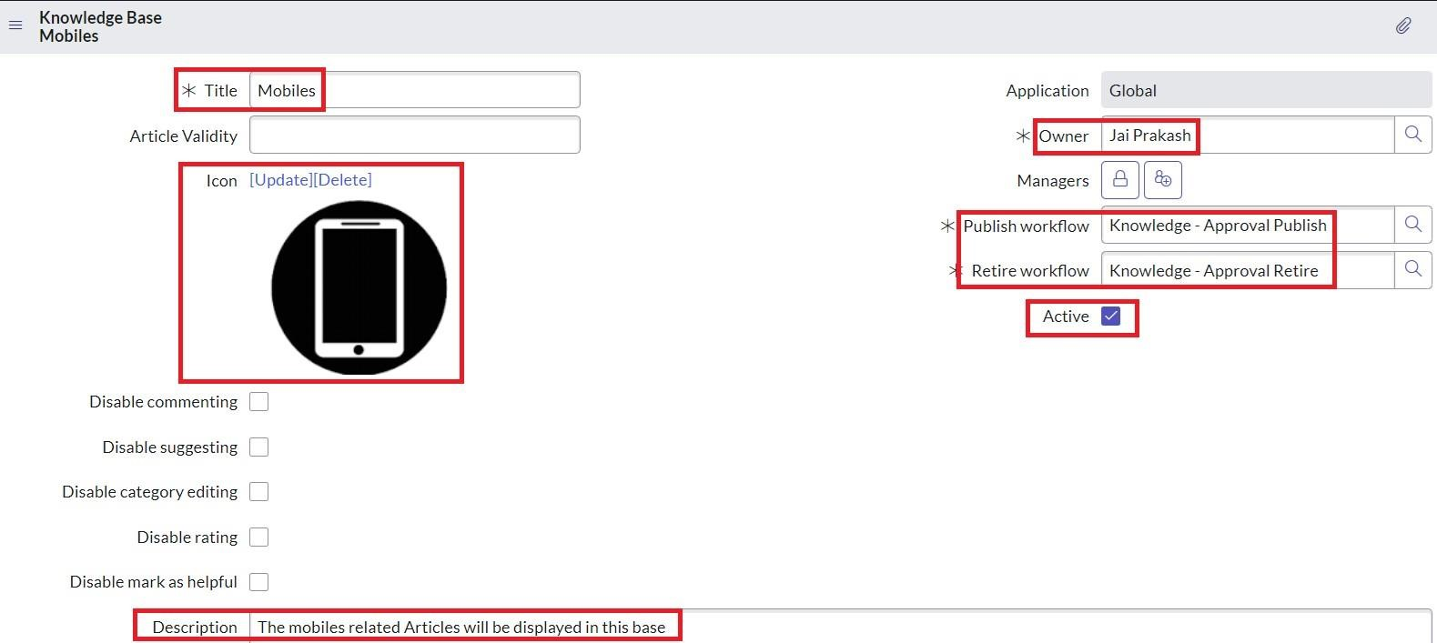

1. After Saving the Knowledge base, it will be seen like below :

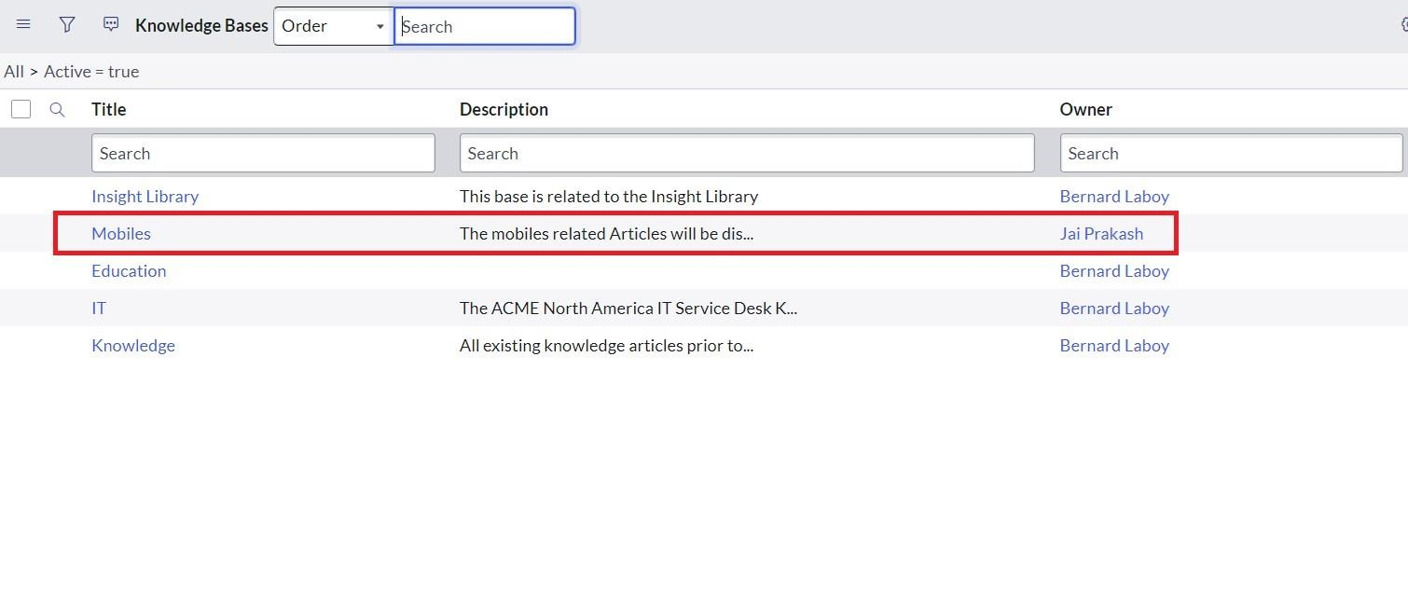

# Activity - 5: Creation of Knowledge Article

1. Go to All >> Search for Knowledge Article.
2. Click on Create an Article



9.



Enter the details as:

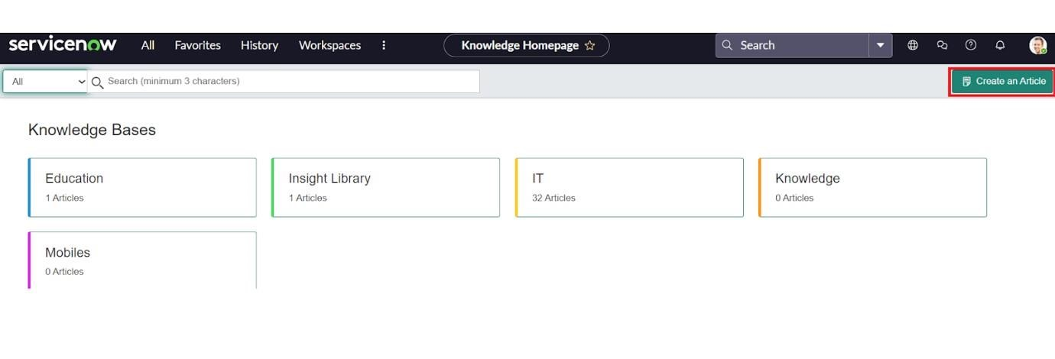

Knowledge base : Select Mobiles

1. For Category : Click on Search >> then ‘+’ icon
2. Add some category pickers as you wish and then click on ok.

For Category : Select Iphone



12.



Enter the details as:

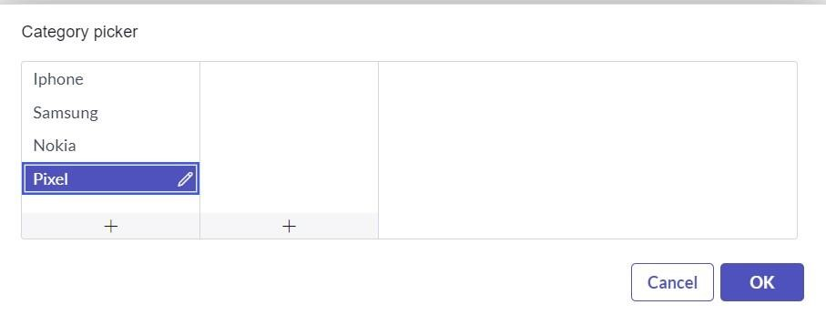

Valid to : Select date

Description : Enter “How to Purchase Apple iPhone 13 Pro from the Service Catalog”

1. In Article Body : Type your Article information.

Product Overview:

Name: Apple iPhone 13 Pro Model:

A2636 (US)

Key Features:

* + Display: 6.1-inch Super Retina XDR display
  + Camera: Pro camera system with 12MP Ultra Wide, Wide, and

Telephoto cameras; Night mode, Deep Fusion, Smart HDR 4,

4K Dolby Vision HDR recording

* + Processor: A15 Bionic chip
  + Storage Options: 128GB, 256GB, 512GB, 1TB
  + Operating System: iOS 15
  + Battery Life: Up to 22 hours talk time
  + Colors: Graphite, Gold, Silver, Sierra Blue

How to Purchase:

* 1. Navigate to the Service Catalog:

* + - Log in to your ServiceNow account. o Click on the "Service Catalog" link from the main menu.
  1. Search for iPhone 13 Pro:

* + - Use the search bar to type "Apple iPhone 13 Pro". oSelect the product from the search results.
  1. Select Configuration:

* + - Choose your preferred storage option and color. oReview the product details and specifications.
  1. Add to Cart:

* + - Click the "Add to Cart" button to add the iPhone 13 Pro to your shopping cart.
  1. Checkout:

* + - Proceed to checkout by clicking the shopping cart icon.
    - Follow the prompts to complete your purchase.

Installation and Setup Instructions:

1. Unbox Your iPhone 13 Pro:

* + - Carefully unbox your new iPhone and remove all protective materials.

2. Power On the Device:

* + - Press and hold the side button until the Apple logo appears.

3. Follow On-Screen Setup Instructions:

* + - Select your language and region. oConnect to a Wi-Fi network. oSet up Face ID and create a passcode. o Sign in with your Apple ID or create a new one.

4. Transfer Data:

* + - If you are upgrading from another iPhone, use the Quick Start feature to transfer your data.
    - Alternatively, restore from an iCloud or iTunes backup.

5. Complete Setup:

* + - Customize your settings and preferences.
    - Download and install any available software updates.

Troubleshooting Common Issues:

1. iPhone Not Powering On:

* + - Ensure the device is charged by connecting it to a power source.
    - Try a forced restart by pressing and quickly releasing the Volume Up button, then the Volume Down button, and

finally, press and hold the side button until the Apple logo appears.

2. Wi-Fi Connectivity Issues:

* + - Toggle Wi-Fi off and on in Settings. oRestart your router and modem. o Reset network settings by going to Settings > General > Reset > Reset Network Settings.

3. Face ID Not Working:

* + - Ensure the TrueDepth camera is not obstructed.
    - Go to Settings > Face ID & Passcode and re-register your face.

Frequently Asked Questions (FAQ):

1. What are the storage options available for the iPhone 13 Pro?

* + - The iPhone 13 Pro comes in 128GB, 256GB, 512GB, and 1TB storage options.

2. Can I use my old SIM card with the iPhone 13 Pro?

* + - Yes, the iPhone 13 Pro supports nano-SIM cards. You can use your existing SIM card or get a new one from your carrier.

3. Does the iPhone 13 Pro support wireless charging?

* + - Yes, the iPhone 13 Pro supports MagSafe and Qi wireless charging.

4. How can I extend the battery life of my iPhone 13 Pro?

* + - Enable Low Power Mode in Settings > Battery.
    - Reduce screen brightness and use Wi-Fi whenever possible. oDisable background app refresh and location services for apps you do not use frequently.

5. What should I do if my iPhone 13 Pro is not responding?

* + - Try a forced restart by following the steps mentioned in the troubleshooting section above.

Contact Support:

If you encounter any issues not covered in this guide, please contact our support team through the ServiceNow portal.

Conclusion:

The Apple iPhone 13 Pro is a powerful and versatile smartphone designed to meet all your needs. By following this guide, you can easily purchase, set up, and troubleshoot your device. Should you need further assistance, our support team is always ready to help.

Enjoy your new iPhone 13 Pro!

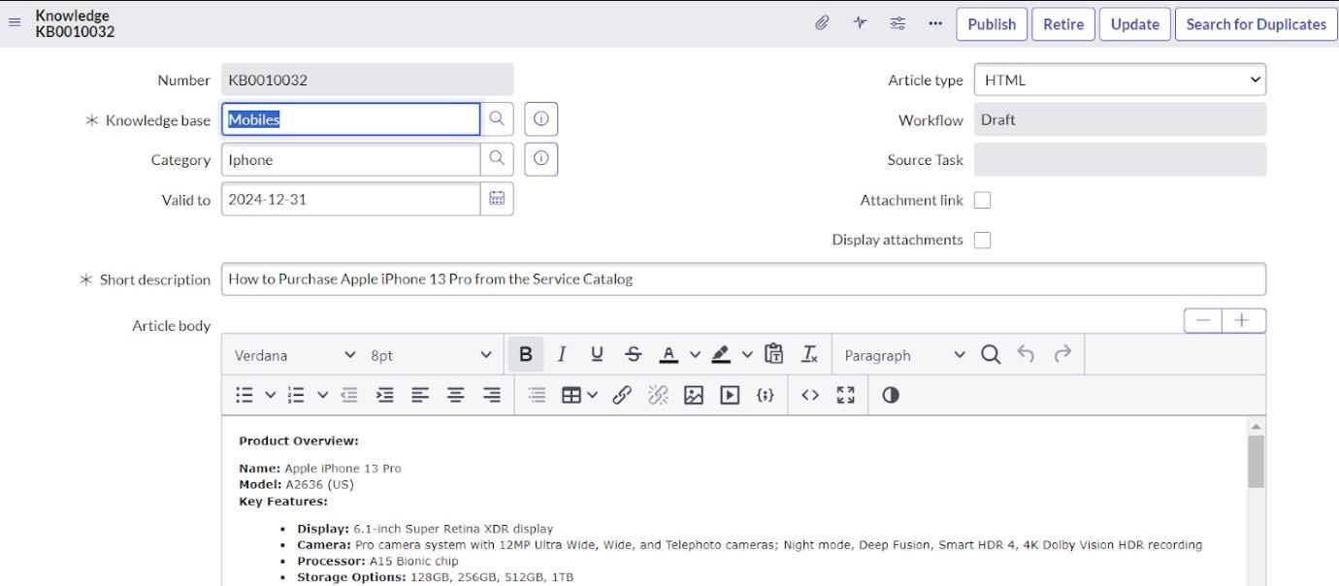

1. After Typing Article click on Submit.

# Activity - 6: Linking the Knowledge Article to Catalog item

1. Go to All >> Search for My Knowledge Article.
2. Open the Knowledge Article we created earlier.
3. Scroll down, you can find Related Catalog Items.
4. Click on Edit and add Apple iPhone 13 pro to Related Catalog Items List.



19.



Click on Save.

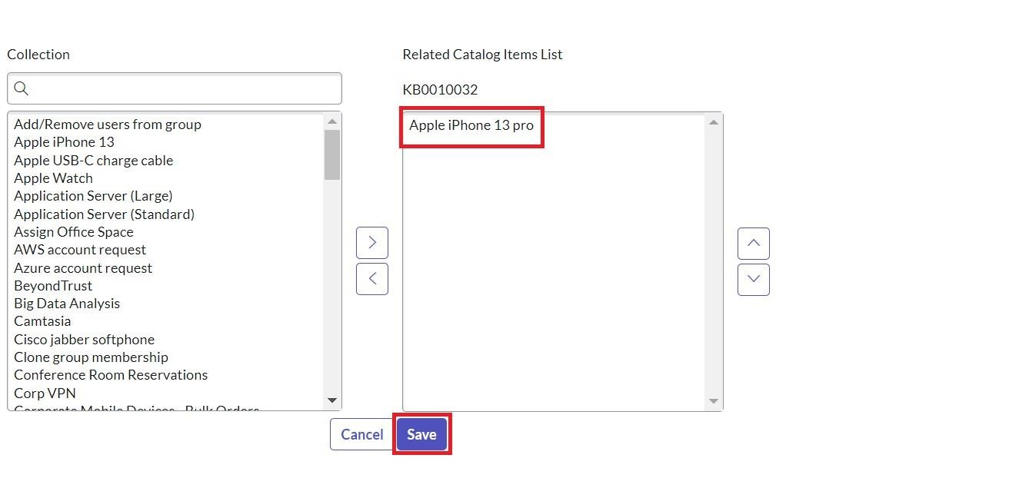

20.



Now click on Publish.

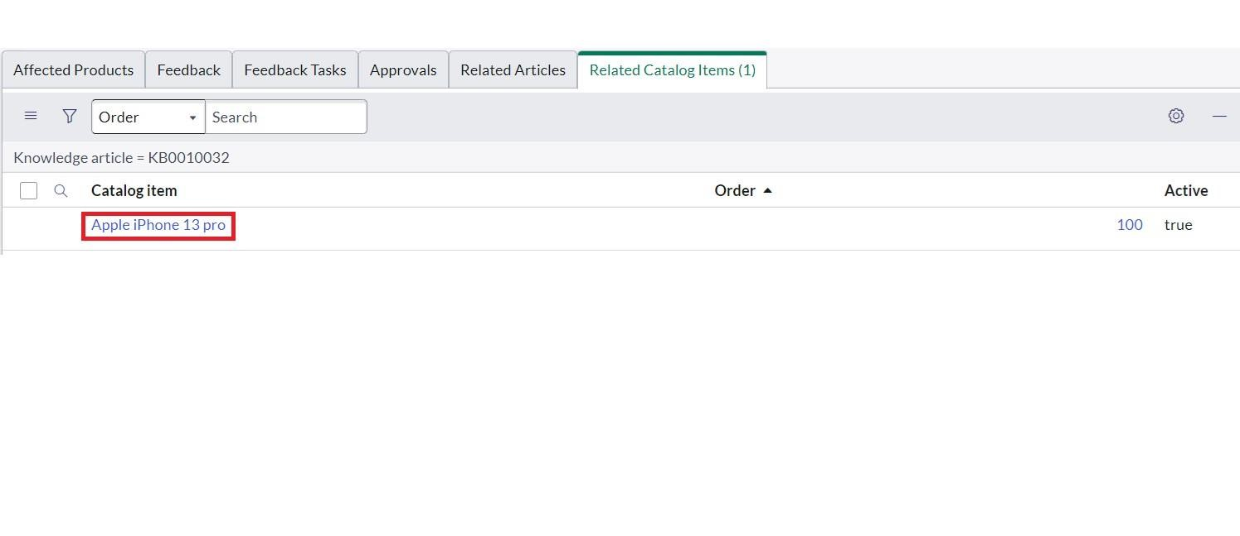

# Activity - 7: Approving the Article

1. Go to All >> Search for My Knowledge Article.
2. Open the Knowledge Article we created earlier.
3. Scroll down, you can find Approvals.
4. Under State, you can find Requested. Click on that

25.

Approve the Article (To do that change the state to Approved)

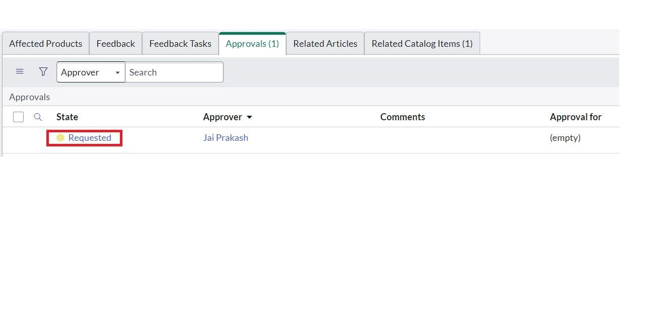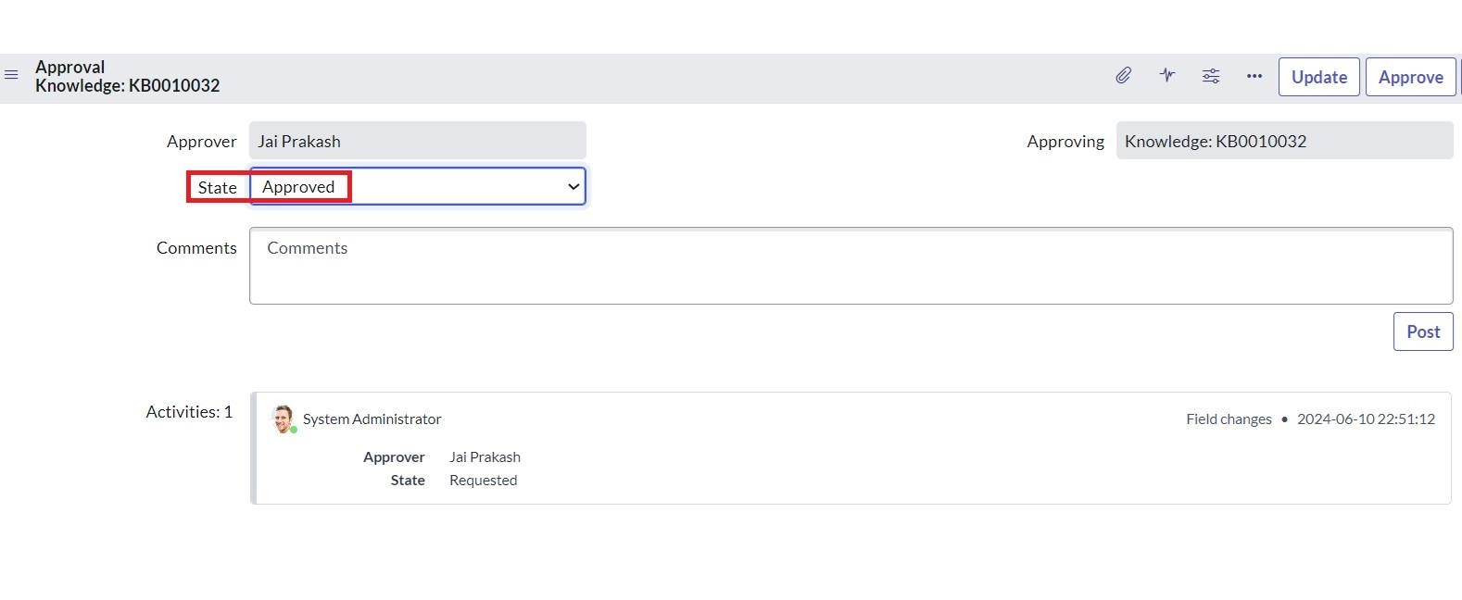

1. Then click on Update.
2. If you scroll down you can see that the Article has been approved.

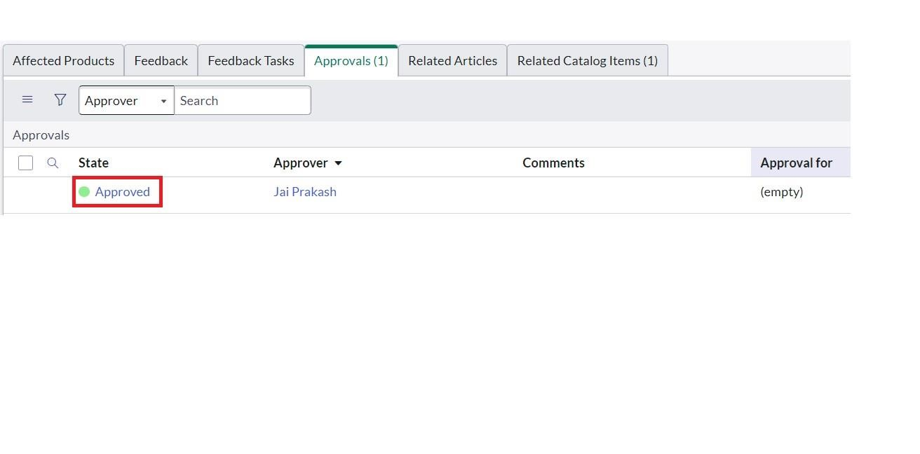

# Activity - 8: Adding Knowledge Base to Service Catalog

1. Go to All >> Search for Portals.



1. Open Portals >> Open Service Portal.
2. Scroll down, Open Knowledge Bases >> Click on Edit.
3. Add Mobiles to Knowledge Bases List.



32.



Click on Update.

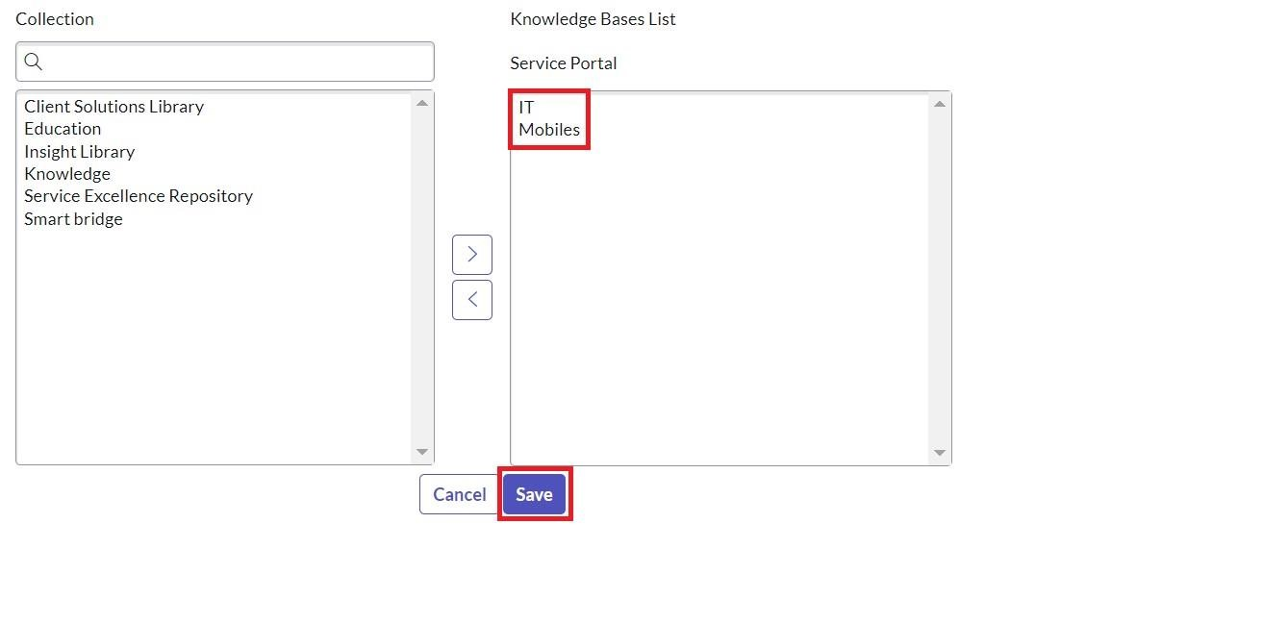

Result :

The comprehensive guide to Apple iPhone 13 Pro has successfully provided an exhaustive understanding of its cutting-edge features, performance enhancements, and user-friendly interface.